1. **VL with Quadratic: data length, regression error, non-selt match threshold, k, alpha, anomalies, time**

(0-15000), 400000, 100, 1, 2.5, (5379-6005)(13883-14730), 00:01:54

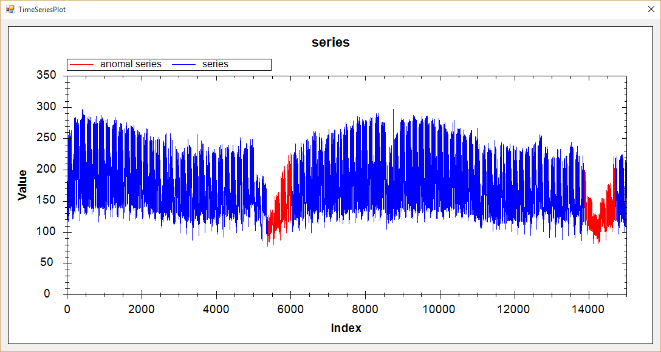

(0-15000), 405000, 100, 1, 2.0, (5383-6009)(14246-14810), 00:01:13

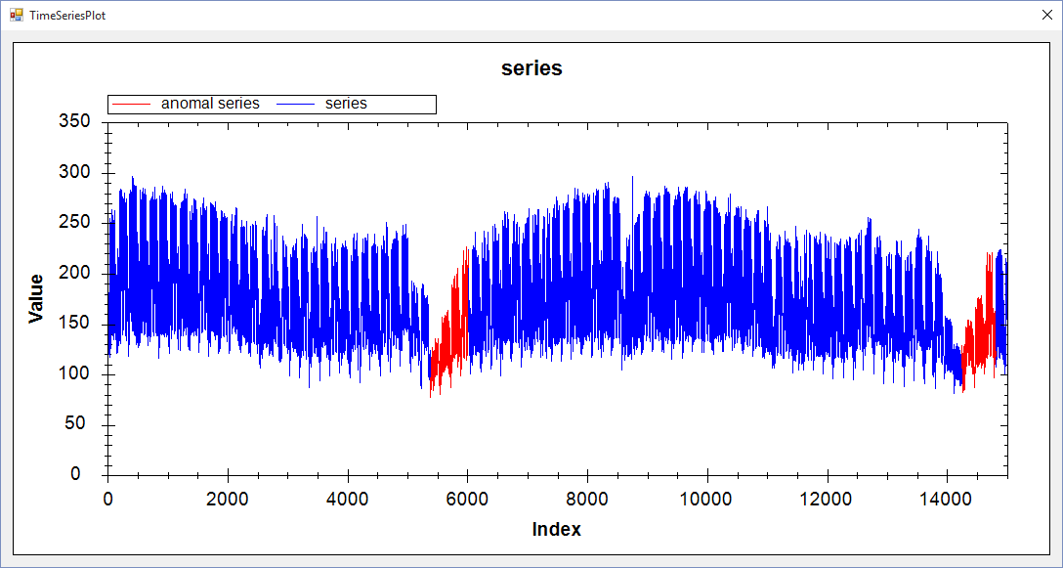

(0-7000), 150000, 100, 1, 4.0, (5356-5771), 00:00:36

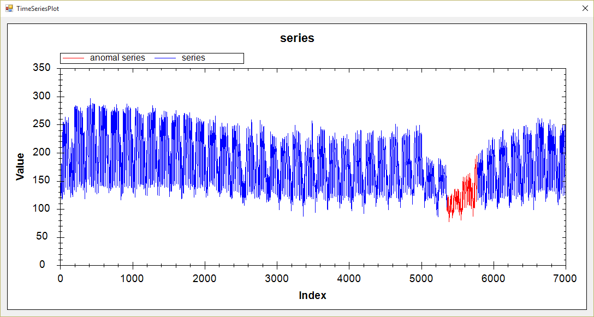

(0-7000), 100000, 100, 1, 4.0, (5331-5663), 00:00:47

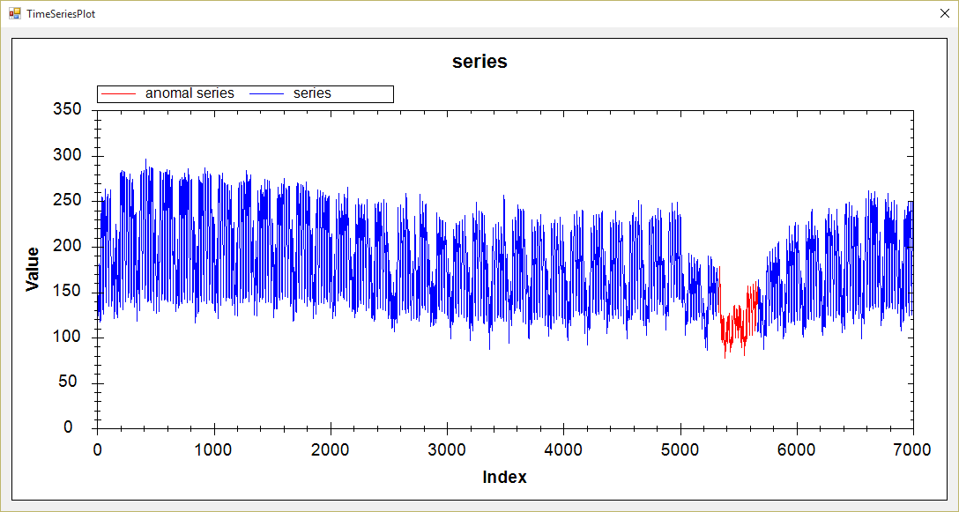

1. **VL with Extrem point: data length, ration, min length, k, alpha, anomalies, time**

(0-7000), 1.8,20,1,3,(5383-5719),00:01:25

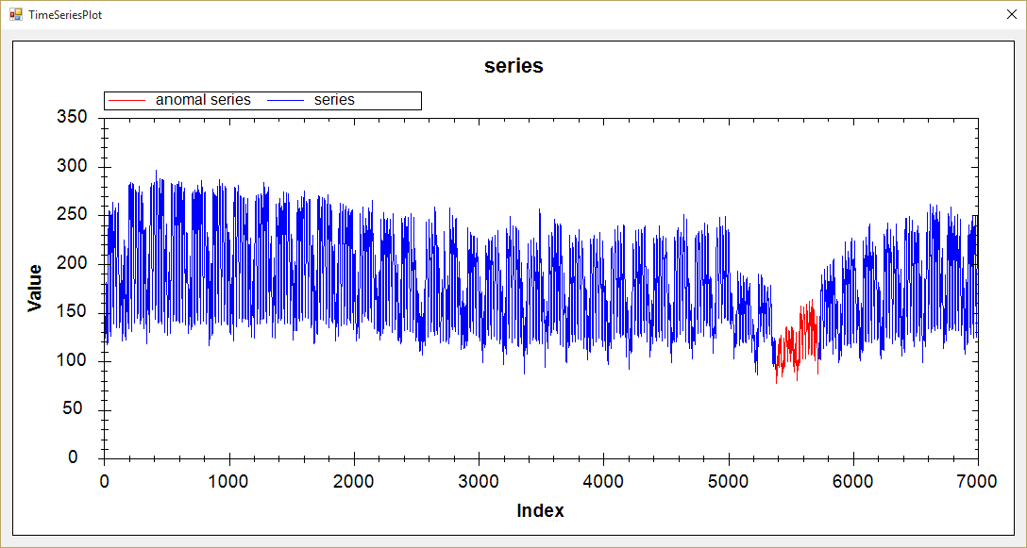

1. **Hot Sax: data length, anomaly length, paa length, discord begin, time**

(0-15000), 1000, 100, 5434, 00:08:10

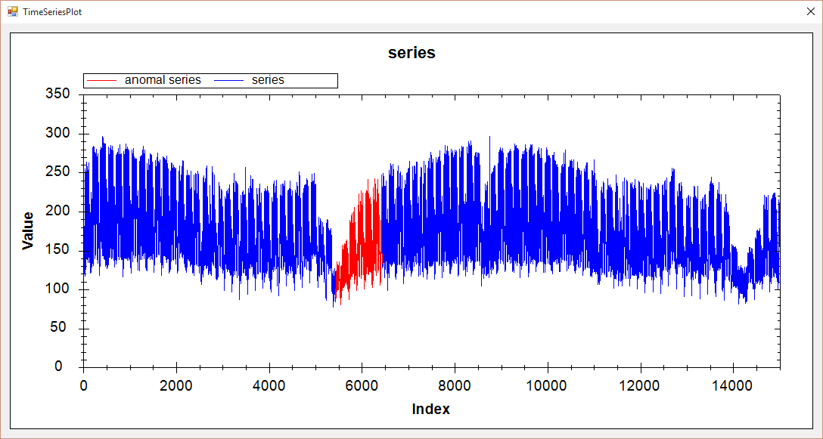

(0-15000), 900, 100, 5464, 00:09:09

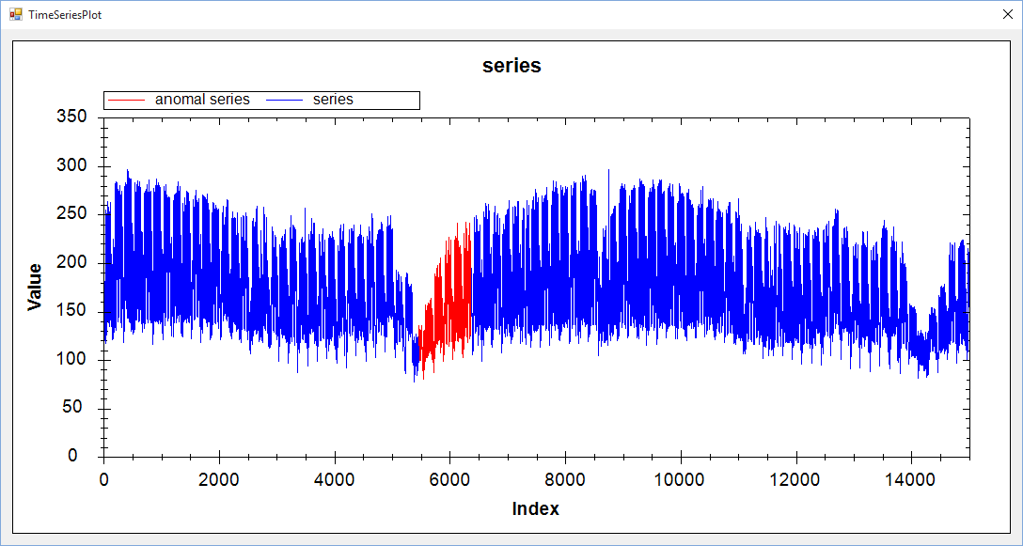

(0-15000), 847, 80, 5471, 00:07:46

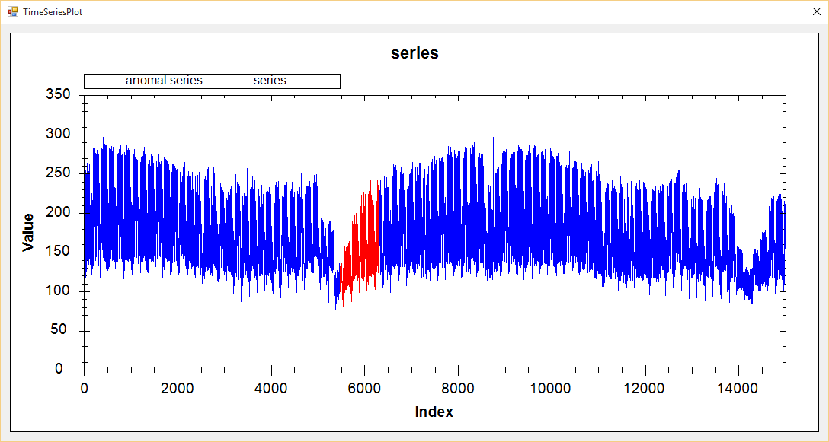

(0-7000), 300, 30, 5343, 00:01:42

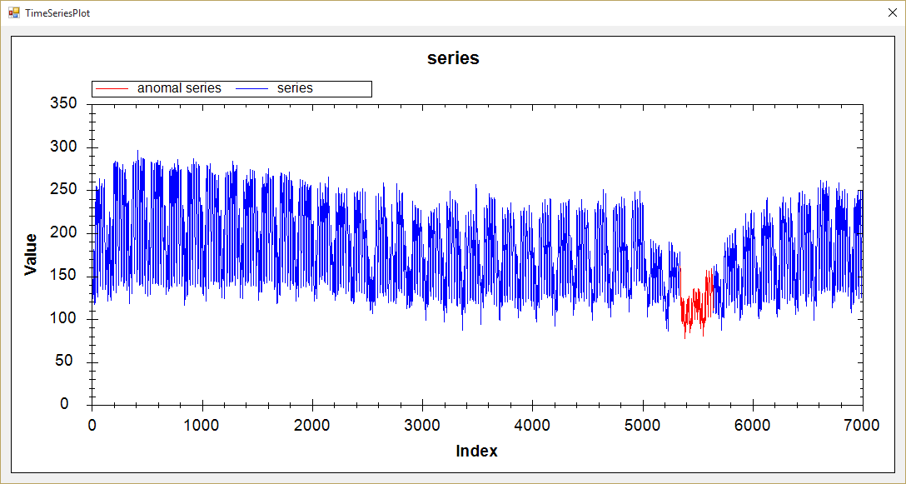

(0-7000), 250, 25, 5353, 00:01:31

